DNS Configuration

What is DNS ?
Domain Name System
Provides resolution of names to IP addresses
and resolution of IP addresses to names.
Defines a hierarchical namespace where each level of
the namespace is separated by a “.”

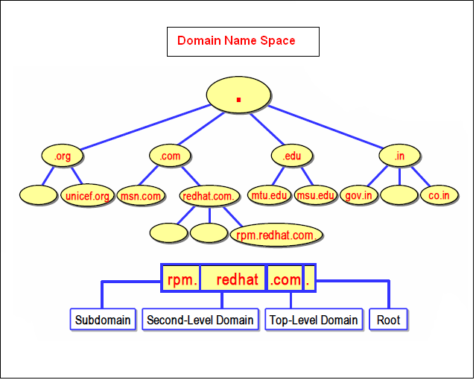

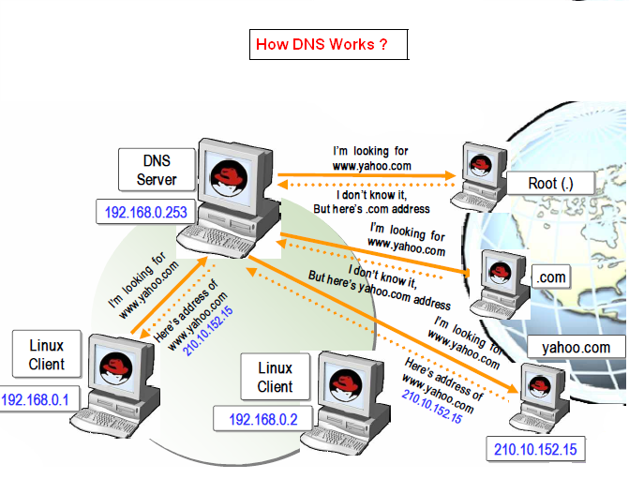

Host File

Host File provides resolution of hostnames to IP addresses.

It can only resolve the names provide in the local host file.

It cannot be used as central Database.

You can add the name and ip address in /etc/hosts

Add the hostname entry/etc/hosts

# Do not remove the following line, or various programs

# that require network functionality will fail.

127.0.0.1 localhost.localdomain localhost
172.16.179.104 server.it.com server
172.16.179.105 client1.it.com client1
172.16.179.106 client2.it.com client2

Save by :wq

Zone

Zone is a storage database which contains
all zone Records
Forward Lookup Zone
Used for Resolving Host Names to IP-Address

It maintains Host to IP Address Mapping Information
Reverse Lookup Zone
Used for Resolving IP-Address to Host Names
It maintains IP Address to Host Mapping Information

Types of Record
SOA Record
The first record in any zone file
NS Record
Identifies the DNS server for each zone
A Record
Resolves a host name to an IP address
CNAME Record
Resolves an alias name to a host name
PTR Record
Resolves an IP address to a host name
MX Record
Used by the mail server

Requirements PACKAGES

bind-chroot-9.2.4-2.i386.rpm

bind-devel-9.2.4-2.i386.rpm

bind-libs-9.2.4-2.i386.rpm

bind-utils-9.2.4-2.i386.rpm

bind-9.2.4-2.i386.rpm

caching-nameserver-7.3-3.noarch.rpm

PORT NUMBERS

53 DNS

Configuration File

/etc/named.conf
SERVICE

named

DAEMON

Named

Install the package by using rpm installation method

[root@Server Packages]# cd /media/Fedora\ 13\ i386\ DVD/Packages/
[root@comp1 ~]# rpm -ivh bind* caching* --force –aid
OR
Install the package by using yum installation method (Installation through Internet)

[root@comp1 ~]# yum install bind* caching*

Open configuration for editing

[root@comp1~]# vi /etc/named.conf

To change the options
/etc/named.conf
zone "it.com" IN {
type master;
file it.for";
};
zone "0.16.172.in-addr.arpa" IN {
type master;
file it.rev";
};
Copying Forward lookup zone file

[root@comp1 ~]# cd /var/named/chroot/var/named/

[root@comp1 named]# cp localhost.zone it.for

Open configuration for editing

[root@comp1 named]# vi it.for

client2 IN A 192.168.0.2
www IN CNAME server
To add the options
$TTL 86400
@ IN SOA server.it.com. root.it.com.(
42 ; serial (d. adams)
3H ; refresh
15M ; retry
1W ; expiry
1D ) ; minimum

IN NS server.it.com.
server IN A 192.168.0.253
client1 IN A 192.168.0.1
client2 IN A 192.168.0.2
www IN CNAME server

Copying Reverse lookup zone file

[root@comp1 ~]# cd /var/named/chroot/var/named/
[root@comp1 named]# cp named.local it.rev
Open configuration for editing

[root@comp1 named]# vi it.rev
To add the options

$TTL 86400
@ IN SOA server.it.com. root.it.com.(
1997022700 ; Serial
28800 ; Refresh
14400 ; Retry
3600000 ; Expire
86400 ) ; Minimum

IN NS server.it.com.
253 IN PTR server.
1 IN PTR client1.
2 IN PTR client2

Open configuration for editing

[root@comp1 ~]# vi /etc/resolv.conf

Add the DNS server IP address in file /etc/resolv.conf

nameserver 172.16.176.104

To restart the DNS services

[root@comp1 ~]# service named restart

Checking Forward Lookup

[root@comp1 ~]# dig server.it.com
[root@comp1 ~]# dig client1.it.com

Checking Reverse Lookup

[root@comp1 ~]# dig -x 172.16.176.104
[root@comp1 ~]# dig -x 172.16.176.105

Checking Name resolution

[root@comp1 ~]# ping server.it.com
[root@comp1 ~]# ping client2.it.com

Open configuration for editing

[root@comp1 ~]# vi /etc/resolv.conf

Add the DNS server IP address in file /etc/resolv.conf
nameserver 172.16.176.104

Dig another PC via FQDN

[root@comp1 ~]# dig server.it.com
[root@comp1 ~]# dig client2.it.com

Dig DNS server IP

[root@comp1 ~]# dig -x 172.16.176.104

Ping another PC via FQDN

[root@comp1 ~]# ping server.it.com
[root@comp1 ~]# ping client2.it.com

Ping another PC via FQDN

[root@comp1 ~]# ping server.it.com

